# PRACTICE PROGRAMS MODULE -1

## SECTION:4

### SECTION-4.1

2.

PROGRAM:

package galToLit;

public class GalToLit {

public static void main(String[] args)

{

double gallons = 10;

double liters = 0;

liters = gallons * 3.785;

System.out.println(gallons + " gallons equals " + liters + " liters");

}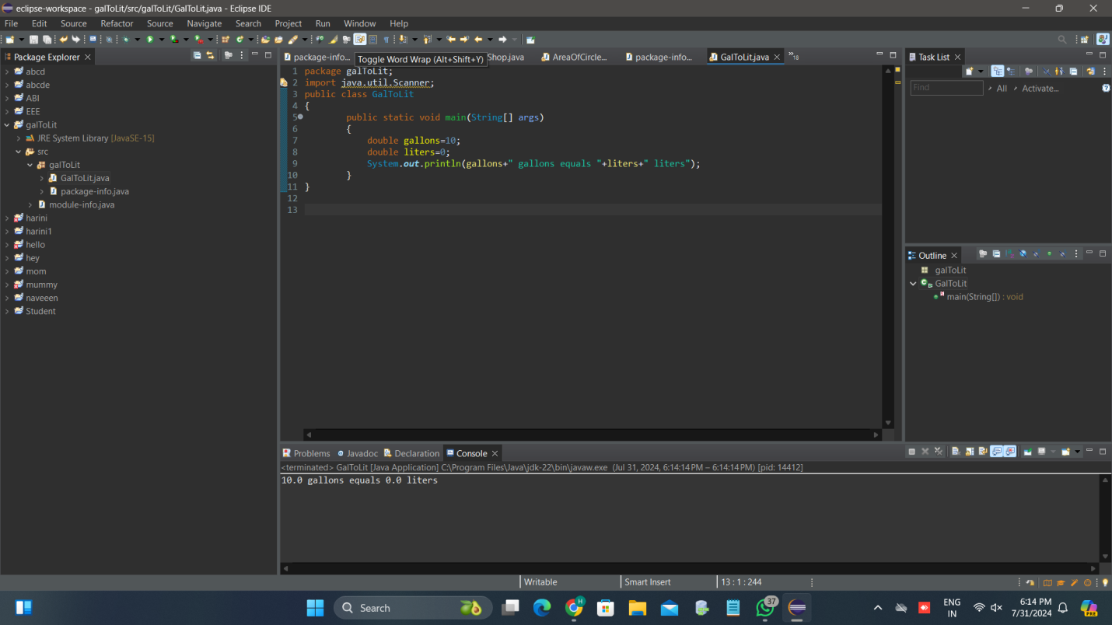

3.

**PROGRAM:**

package galToLit;

import java.util.Scanner;

public class GalToLit

{

public static void main(String[] args)

{

double gallons;

double liters;

Scanner in = new Scanner(System.***in***);

System.***out***.print("Enter the number of gallons: ");

gallons = in.nextDouble();

liters = gallons * 3.785;

System.***out***.println(gallons + " gallons equals " + liters + " liters");

in.close();

}

}

**OUTPUT:**

Enter the number of gallons: 5

5.0 gallons equals 18.925 liters

